**Assignment – 1**

**Question No. 1 What is SDLC ?**

Software development life cycle is structure imposed on development of a Software that defined the Process for Planning, Implementation, Testing, Documentation, deployment, ongoing maintenance and Support.

**Question No. 2 What is software testing?**

Software is a process used to identify the correctness, Completeness and Quality of Developed Computer Software.

**Question No. 3 What is agile methodology?**

Agile SDLC Model is a Combination of Iterative and Incremental process model with focus on process adaptability and customer satisfaction by rapid delivery of working software product.

**Question No. 4 What Is SRS?**

A software Requirement specification is a complete description of the behavior of the system to be developed.

**Question No. 5 What Is oops?**

* Object oriented programing system
* Black Box Testing

**Question No.6 Write the basic Concept of Oops ?**

* Object
* Class
* Encapsulation
* Inheritance
* Polymorphism
* Abstraction

**Question No. 7 What is Object ?**

* Its an Instances of an class

**Question No. 8 What is Class?**

* Class is an Collection of data member ( Variable ) and member function ( Process , Method ) with its behaviors.

**Question No. 9 What is encapsulation?**

* Wrapping up of data into single unit private your data member Function.

**Question No. 10 What is inheritance?**

* Property of parent class extends into child class.
* Property of super class extent into subclass.

**Question No. 11 What is polymorphism?**

* Ability to take one name having many form or multiple forms.

**Question No. 12 Write SDLC Phases with Basic Introduction.**

Software development life cycle is structure imposed on development of a Software that defined the Process for Planning, Implementation, Testing, Documentation, deployment, ongoing maintenance and Support.

In other way SDLC is a Roadmap for creating , testing , and maintaining software with different development models.

**There is six step process**

1. Requirement Collection
2. Analysis
3. Design
4. Implementation
5. Testing
6. Maintenance

**Question No. 13 Explain the phases of the waterfall model.**

The Classical software life cycle the softewer development as step by step between the various development phases.

* Requirement Collection
* Analysis
* Design
* Implementation
* Testing
* Maintenance

**1.Requirement Gathering**

* Features
* Usage scenarios
* Plan for change
* The final system is delivered

**Three types of problem arise**

1. Lack of clarity
2. Requirement Confusion

Requirement are interconnected, impact each other in a project.

1. Requirement Amalgamation

Types of Requirement

1. Functional requirement
2. Non- Functional Requirements

**2 Analysis phase** – creating Clear record what system needs to achieve or deliver

**3 Design Phase –** We figure out How to Build It. And

Analysis is about ‘’ what We Need “ and design is about how we will achieve it .

**Design Phases**

* Design Architecture document
* Implementation Plan
* Performance Analysis

**4 Implementation phases**

In Implementation, the team build what’s plan ,addressing Quality and errors.

**5 Testing phases**

Quality is very important. And testing is process of maintaining Quality.

**6 Maintenance**

Maintenance is a Process of Changing a System after it has been deployed.

**Types of Maintenance**

1.Corrective Maintenance – Identifying And Repairing Defects.

2. Adaptive Maintenance – Adaptive The New Platform.

3. Perfective Maintenance – New Product

**Question No. 14 write phases of the spiral model**

* Planning
* Risk Analysis
* Engineering
* Customer Evaluation

**Question No. 15 Write agile manifesto Principles**

1. Individual Interaction
2. Working software
3. Customer collaboration
4. Responding to Change

**Question No. 16 Explain working methodology of agile model and also write pros and cons.**

**Agile methodology**

* Crum
* Kanban

**Agile pros**

* Is a very realistic approach to software development
* Promote teamwork and cross training
* Functionality can be developed rapidly and demonstrated
* Resource requirement are minimum

**Agile cons**

* Not suitable for handling complex dependencies
* More risk of sustainability, maintainability and extensibility
* Depends heavily on customer interaction , so if customer is not clear , team can be driven in wrong direction

**Question No. 17 Draw usecase on online book shopping?**

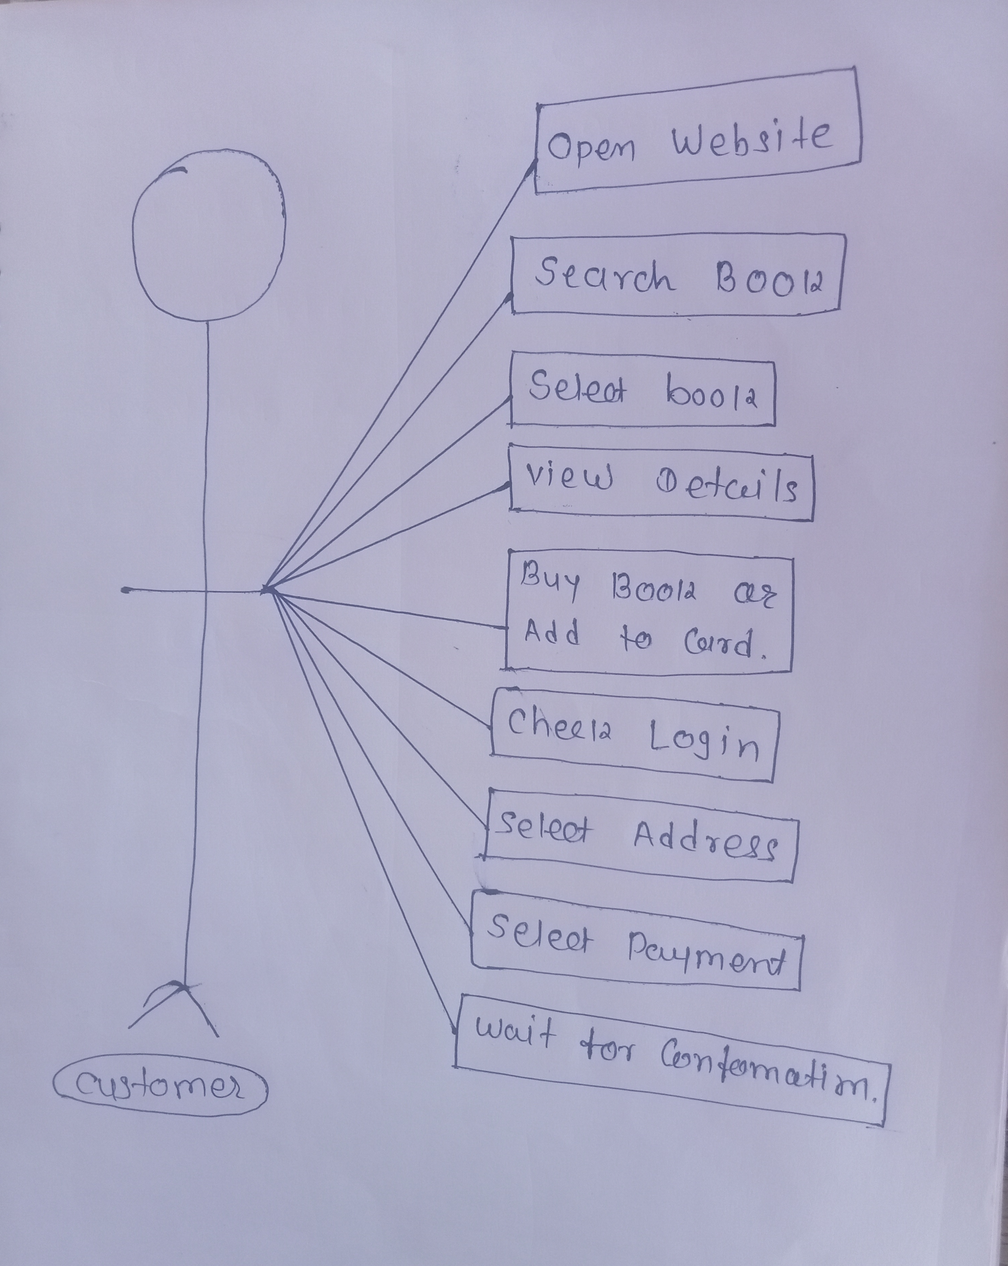

**Question No. 18 Draw usecase on online bill payment system ( paytm )**

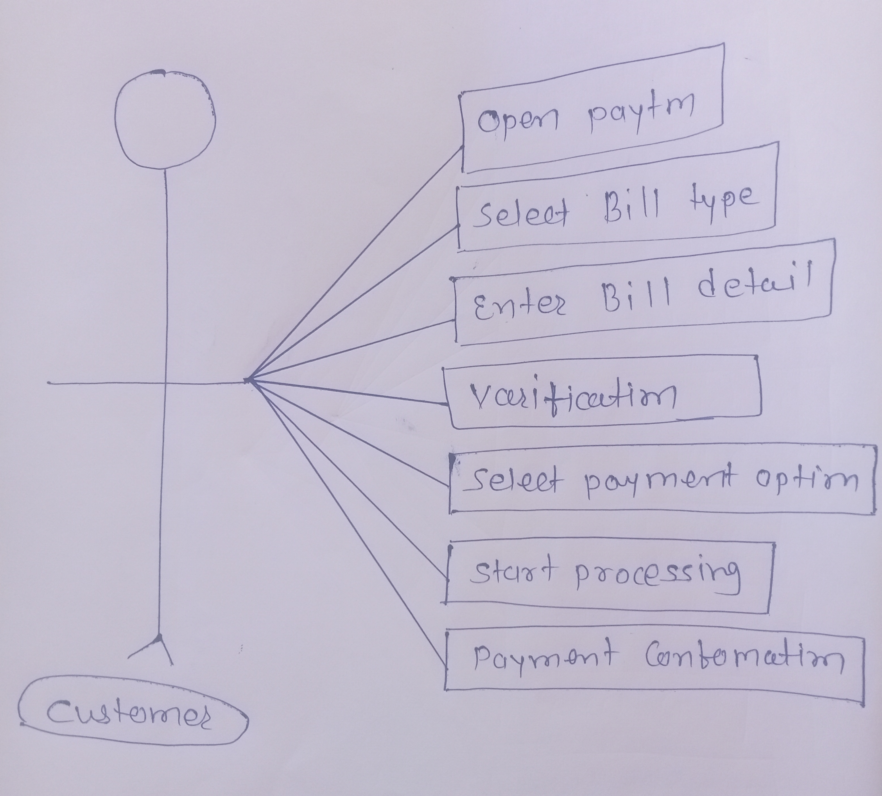

**Question No. 19 Draw usecase on online shopping product using COD**

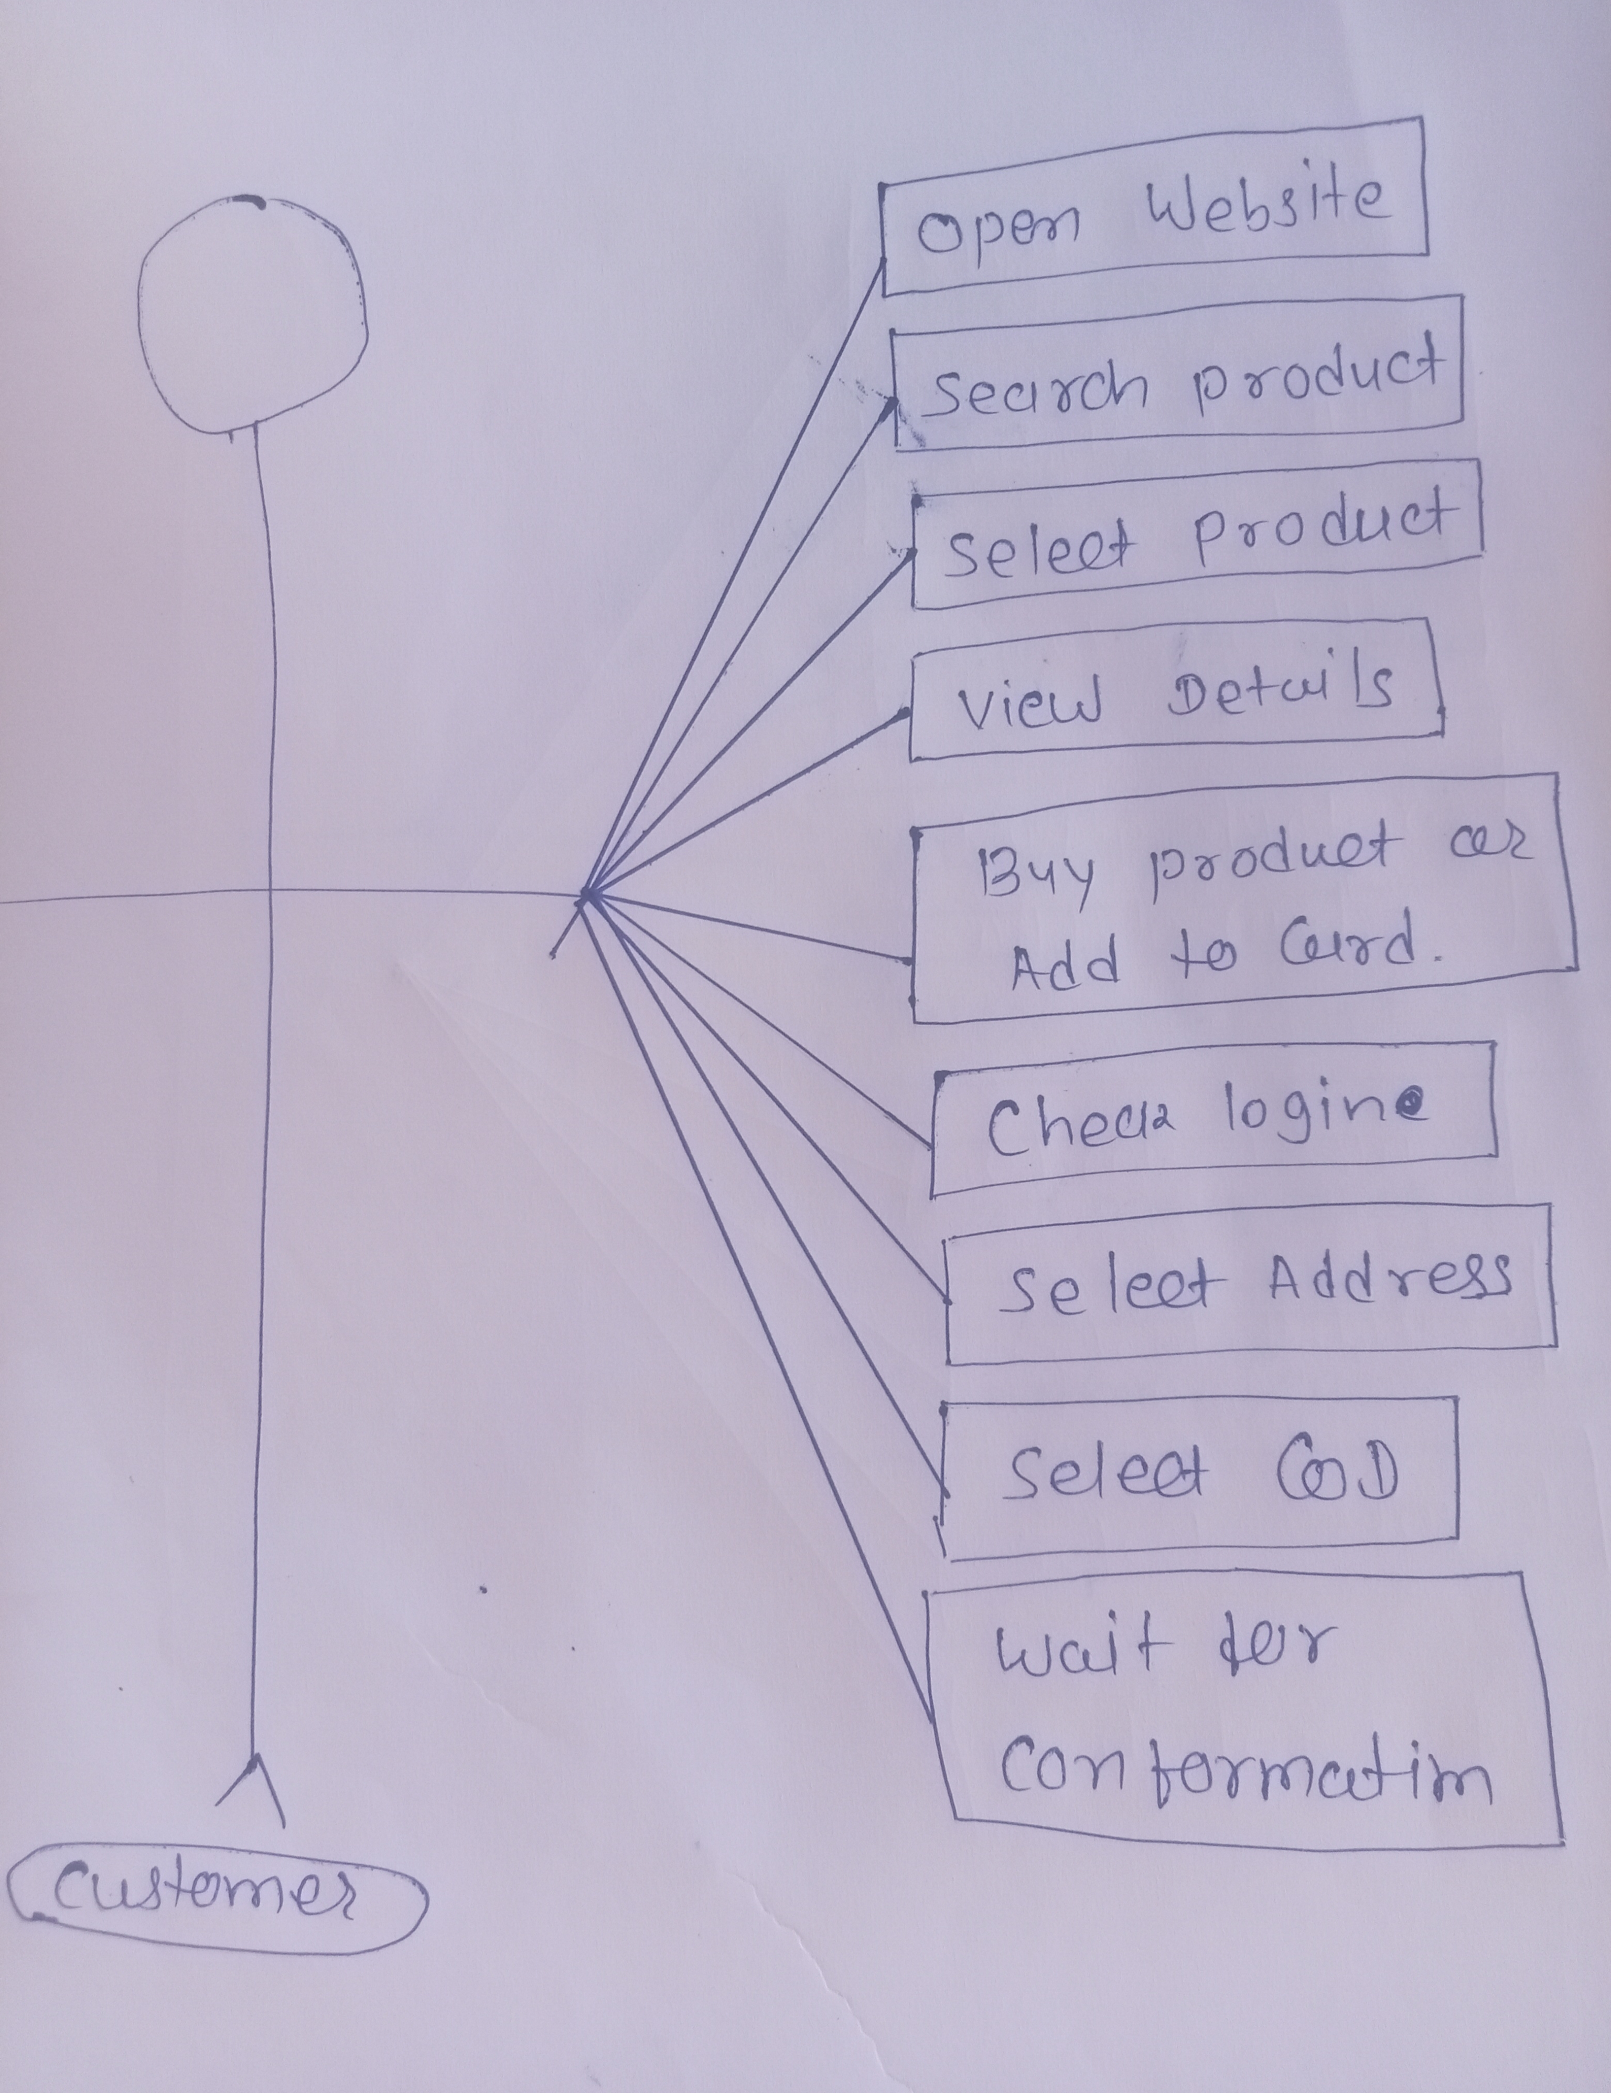

**Question No. 20 Draw usecase on online product using payment gateway**

